Contents

1 🔧What’s New 2

2 🚀 Fixed Defects 2

3 Accessibility fixes 2

4 ⭐ Improvements 2

5 🚀 Deployments 3

5.1 Infrastructure 3

5.2 CDN 4

5.3 Web Apps 4

5.4 Mobile 4

5.5 B2C Tenant Policy Files 4

6 💻 Reviewers 5

7 Appendix 6

7.1 Post Deployment Verification 6

7.2 Running Pipeline from Tags 6

Release Notes

# 🔧What’s New

New user stories delivered:

|  |  |  |
| --- | --- | --- |
| User Story Id | Title | State |
| [1362](https://dev.azure.com/TASMUCP/TASMU%20Central%20Platform/_workitems/edit/1362) | As a B2C mobile app user, I want to allow/disallow geo tracking feature in TASMU app so that it can be used to show my location and and e-services based on my location sharing preference | DOD Ready |
| [2119](https://dev.azure.com/TASMUCP/TASMU%20Central%20Platform/_workitems/edit/2119) | Meta tags in the content published | DOD Ready |
| [2128](https://dev.azure.com/TASMUCP/TASMU%20Central%20Platform/_workitems/edit/2128) | 404 not found page | DOD Ready |
| [14249](https://dev.azure.com/TASMUCP/TASMU%20Central%20Platform/_workitems/edit/14249) | As an end user, I should be able to allowed/disallow services based on my account status. | DOD Ready |

# 🚀 Fixed Defects

The following bugs reported in SIT are addressed in the current interim build –

|  |  |  |  |
| --- | --- | --- | --- |
| ID | Title | Severity | Priority |
| [34056](https://dev.azure.com/TASMUCP/TASMU%20MSI/_workitems/edit/34056) | FN-My TASMU App - iOS - Payment method can't be saved | 3 - Medium | 1 |
| [34298](https://dev.azure.com/TASMUCP/TASMU%20MSI/_workitems/edit/34298) | FN-B2C- SignUp/ Registration: Confirm password doesn't match password error message is wrong | 3 - Medium | 2 |
| [34509](https://dev.azure.com/TASMUCP/TASMU%20MSI/_workitems/edit/34509) | FN/UI-B2B Marketplace-Password field does not show -Showpassword icon | 3 - Medium | 2 |
| [34981](https://dev.azure.com/TASMUCP/TASMU%20MSI/_workitems/edit/34981) | FN-B2B-B2C-Mobile Unexpected scrolling behavior in chatbot | 3 - Medium | 2 |
| [34992](https://dev.azure.com/TASMUCP/TASMU%20MSI/_workitems/edit/34992) | FN-Portal-UAT-Unable to add Payment Preference | 3 - Medium | 2 |
| [35033](https://dev.azure.com/TASMUCP/TASMU%20MSI/_workitems/edit/35033) | FN-B2B-404 error is shown when click On Terms And Conditions while create an organisation account | 3 - Medium | 2 |
| [35038](https://dev.azure.com/TASMUCP/TASMU%20MSI/_workitems/edit/35038) | FN-B2B-B2C-No results found page is displayed when searching empty string | 3 - Medium | 2 |
| [35040](https://dev.azure.com/TASMUCP/TASMU%20MSI/_workitems/edit/35040) | FN-B2B- Anonymous can't find news using search box | 3 - Medium | 2 |

# Accessibility fixes

None

# ⭐ Improvements

**None**

# 🚀 Deployments

## Infrastructure

Pull Request – <None>

Steps:

1. Review below secrets for payment gateway
   1. PaymentGWSettings-GetPaymentPreferenceServiceURL
   2. PaymentGWSettings-UpdatePaymentPreferenceServiceURL
2. Check the secrets seeded for any hidden characters. Following website is one way to paste the string online and check for hidden chars - <https://www.soscisurvey.de/tools/view-chars.php>

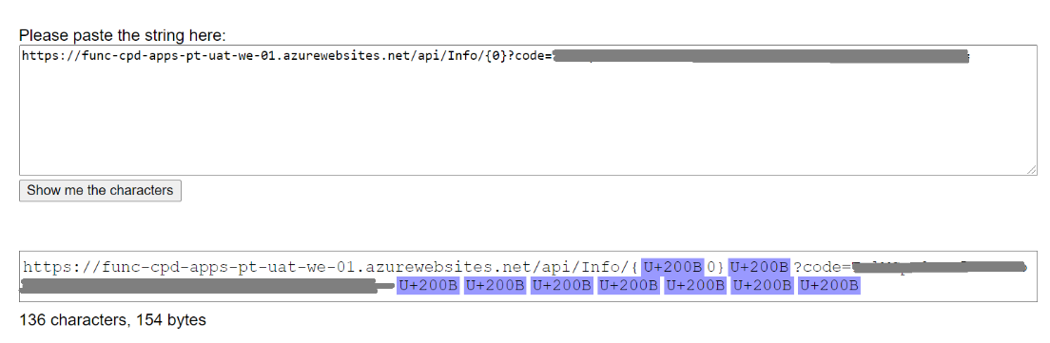

1. Remove the hidden characters from the secret string and update the secret value.
2. Run CD-AppConfigurations-Master-Release to restart the pods.

## CDN

|  |  |
| --- | --- |
| **Tag** | **Pipeline Name** |
| SIT_CDN_21Apr2021 | [CD-CDNContainer-Prd-Release](https://dev.azure.com/TASMUCP/TASMU%20Central%20Platform/_build?definitionId=1019) |

## Web Apps

|  |  |
| --- | --- |
| **Tag** | **Pipeline Name** |
| SIT_Web_21Apr2021 | [CD-WebApps-Prd-Release](https://dev.azure.com/TASMUCP/TASMU%20Central%20Platform/_build?definitionId=1020) |

## Mobile

|  |  |  |
| --- | --- | --- |
| **Platform** | **Build Id** | **Pipeline Link** |
| Android | 40314 | <https://dev.azure.com/TASMUCP/TASMU%20Central%20Platform/_build/results?buildId=40314&view=results> |
| iOS | 40315 | <https://dev.azure.com/TASMUCP/TASMU%20Central%20Platform/_build/results?buildId=40315&view=results> |

## B2C Tenant Policy Files

1. Upload new policy files. Source – [Tag - SIT_Web_21Apr2021](https://dev.azure.com/TASMUCP/TASMU%20Central%20Platform/_git/web-apps?version=GTSIT_Web_21Apr2021)
   1. B2C_1A_B2B_PasswordChange_<env>.xml
   2. B2C_1A_B2B_PasswordReset_<env>.xml
   3. B2C_1A_B2B_TrustFrameworkBase_<env>.xml
   4. B2C_1A_B2B_TrustFrameworkExtensions_<env>.xml
   5. B2C_1A_BO_TrustFrameworkBase_<env>.xml
   6. B2C_1A_BO_TrustFrameworkExtensions_<env>.xml
   7. B2C_1A_PasswordChange_<env>.xml
   8. B2C_1A_PasswordReset_<env>.xml
   9. B2C_1A_TrustFrameworkBase_<env>.xml
   10. B2C_1A_TrustFrameworkExtensions_<env>.xml
2. Please apply any B2C policy customizations selectively done for pre prod environment. Eg: Disabling email verification check on registration.

# 💻 Reviewers

|  |  |
| --- | --- |
| Prepared By | Manvir Kaur, Sumit Gupta, |
| Company name | Microsoft |
| Reviewed by | Ravi Sankar Pillutla, Anil Erkek, Abhishek Ghosh, Subhajit Chatterjee, Gareeb Navas T M, Mecit Atmaca |
| Approved by | Ashwani Sharma |

# Appendix

## Post Deployment Verification

1. Function Apps Running
2. <https://func-cpp-apps-ckan-pre-we-01.azurewebsites.net/>
3. <https://func-cpp-apps-qnasync-pre-we-01.azurewebsites.net/>
4. <https://func-cpp-apps-luistra-pre-we-01.azurewebsites.net/>
5. <https://func-cpp-apps-intbpa-pre-we-01.azurewebsites.net/>
6. <https://func-cpp-apps-intntf-pre-we-01.azurewebsites.net/>
7. <https://func-cpp-apps-pt-pre-we-01.azurewebsites.net/>
8. Marketplace Portal - <http://marketplace.pre.sqcp.qa/en/>
9. Bot – Chat with bot on marketplace
10. My Tasmu Portal - <http://mytasmu.pre.sqcp.qa/en/>
11. Account Portal - <http://account.pre.sqcp.qa/en/>
12. Admin Portal Portal - [http://cpadmin.pre.sqcp.qa](http://cpadmin.pre.sqcp.qa/)  (Login screen should come)
13. API Config access - <https://api.pre.sqcp.qa/config/api/feature>
14. Open Data Portal - <https://opendata.pre.sqcp.qa/>

## Running Pipeline from Tags

